**Algorithm Investigation Notes**

**Dijkstra’s Algorithm**

**Fundamental main notes**

* Dijkstra's algorithm computes length of the shortest path from the source to each of the remaining vertices in the graph.
* This algorithm was pioneered by Edsger W. Dijkstra in 1956 and published three years later
* Common use cases are GPS systems, Computing Network Routing systems, Social Networks and Telephone Networks.
* A common example for Dijkstra is representing nodes as cities and edges as available paths between cities
* Dijkstra algorithm is a greedy algorithm, meaning, it performs a ‘blind’ search which wastes time.
* It also cannot handle negative edges which could lead to acyclic graphs which will produce the wrong result.
* Another small disadvantage is that the time complexity for this algorithm is O(n^2) where n is the number of nodes.
* However, the time complexity can be improved to O(E log V) if using a adjacency list with a binary heap

Videos that helped me understand Dijkstra’s Algorithm:

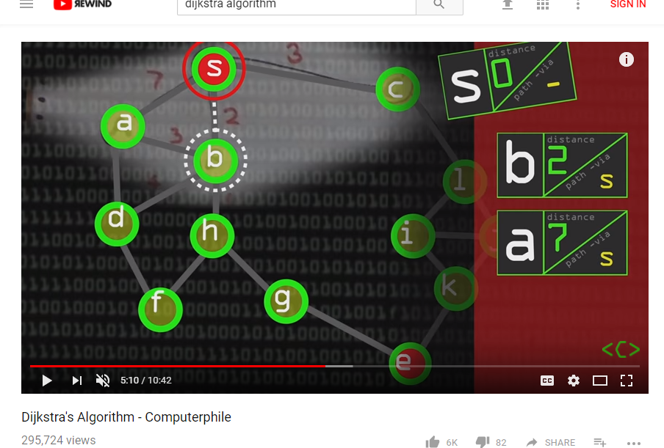

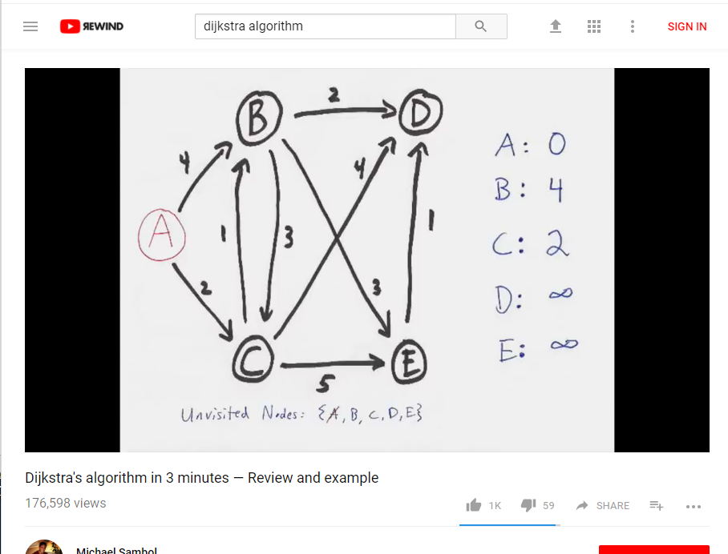

Books that helped me under Dijkstra’s Algorithm:

Algorithms by Robert Sedgewick

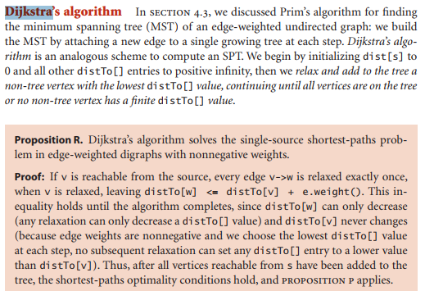

Pseudo Code

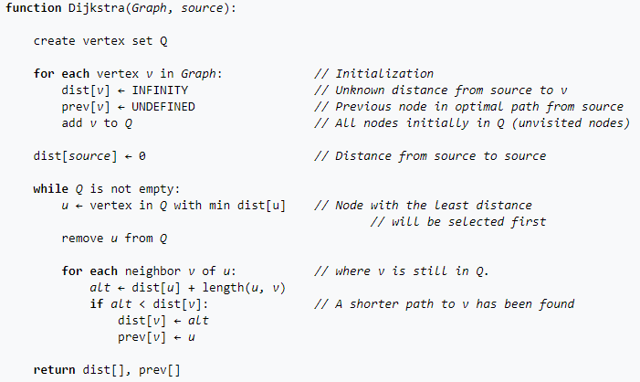

Other Sources:

<https://en.wikipedia.org/wiki/Dijkstra%27s_algorithm>

http://www.geeksforgeeks.org/greedy-algorithms-set-6-dijkstras-shortest-path-algorithm/

<https://www.cs.auckland.ac.nz/software/AlgAnim/dijkstra.html>

<http://math.mit.edu/~rothvoss/18.304.3PM/Presentations/1-Melissa.pdf>

**Kruskal’s Algorithm**

Videos that helped with Kruskal’s algorithm research

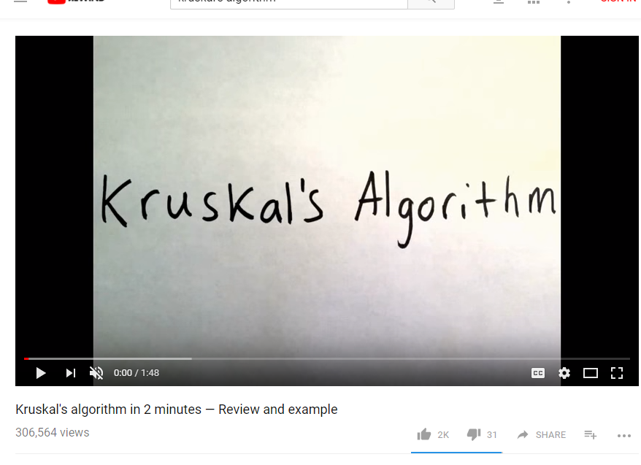

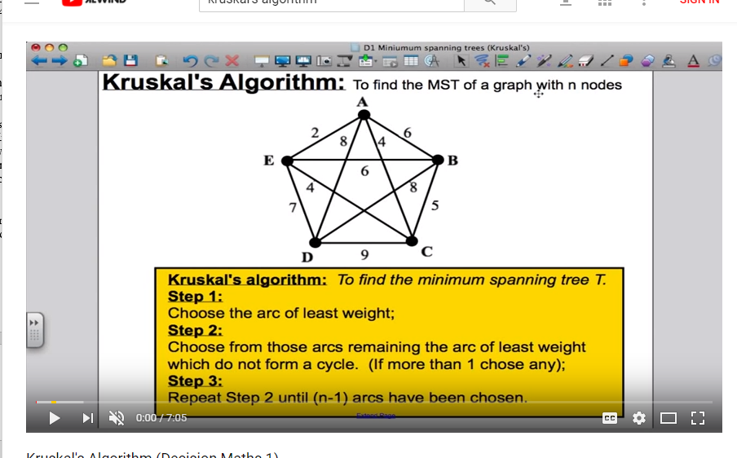

Books that helped with Kruskal’s algorithm research

Algorithms by Robert Sedgewick

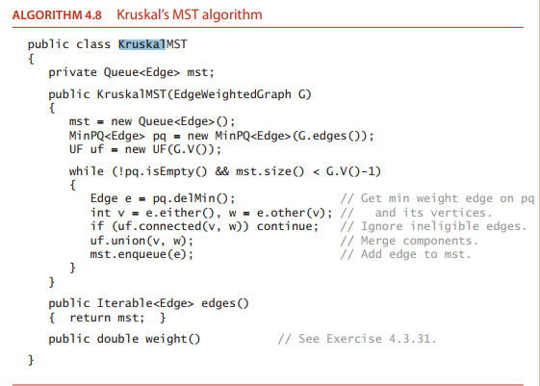

**Fundamental main notes**

* Kruskal’s algorithm is a minimum spanning tree algorithm which finds an edge of the least possible weight that connects any two trees in a forest.
* This algorithm was conceived by Joseph Kruskal in his book Proceedings of the American Mathematical Society in 1956
* Greedy Algorithm
* Finds Minimum Spanning Tree.
* Usages will be Network Design in fields such as telephone, electrical, computer and roads
* The time complexity for Kruskal’s Algorithm is O (E log V) where E is the number of edges and V is the number of vertices.

Psuedo Code



Other Sources:

<https://en.wikipedia.org/wiki/Kruskal%27s_algorithm>

<http://www.geeksforgeeks.org/greedy-algorithms-set-2-kruskals-minimum-spanning-tree-mst/>

<http://blog.hackerearth.com/kruskal-algorithm-minimum-spanning-tree-example>

**Prim’s Algorithm**

Videos that helped me understand Prim’s Algorithm

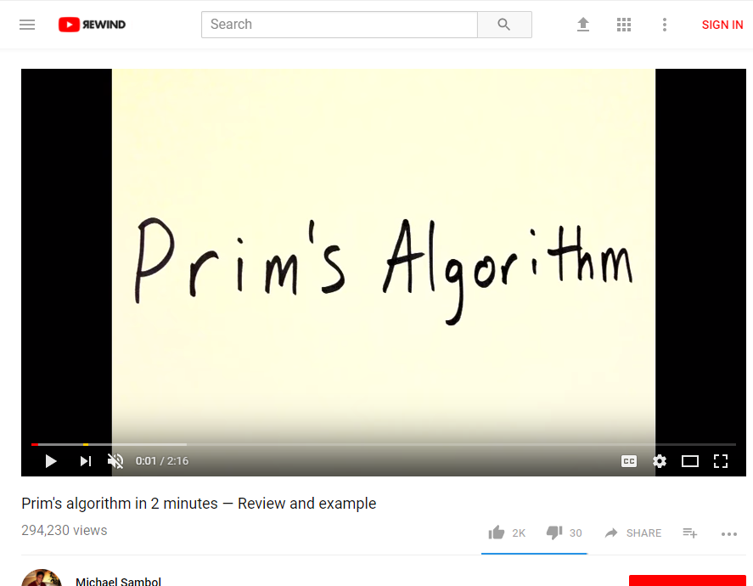

Books that helped me understand Prim’s Algorithm

Algorithms by Robert Sedgewick

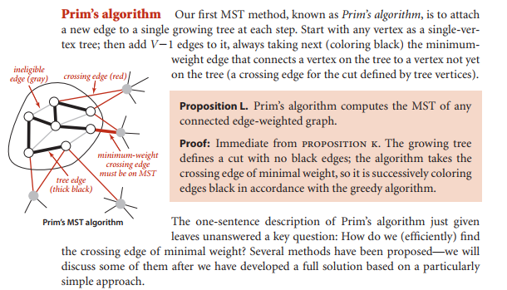

* Prim’s algorithm is also a greedy algorithm which finds a minimum spanning tree for a weighted undirected graph.
* This algorithm was created by Czech mathematician Vojtěch Jarník. This was then rediscovered and republished by Robert C Prim in 1957
* Prim’s algorithm starts with a vertex.
* Prim’s algorithm selects the edge to nodes that are connected to each other.
* The time complexity from prims algorithm is O(n^2) where n is the amount of nodes present.

Other Sources:

<https://en.wikipedia.org/wiki/Prim%27s_algorithm>

<http://www.geeksforgeeks.org/greedy-algorithms-set-5-prims-minimum-spanning-tree-mst-2/>

<https://www.tutorialspoint.com/data_structures_algorithms/prims_spanning_tree_algorithm.html>

<https://stackoverflow.com/questions/1195872/kruskal-vs-prim>

Pseudo Code:

